An
Industry Oriented Mini Project Report
on

PERSONAL EXPENSE TRACKER

APPLICATION

Submitted in partial fulfillment of the requirements for the award of degree
BACHELOR OF TECHNOLOGY

IN

INFORMATION TECHNOLOGY

Submitted By
P.RAHUL REDDY | 237Z1A1248
Under the Guidance of
Mr.K.Anil kumar

Assistant Professor



SCHOOL OF ENGINEERING
Department of Information Technology

NALLA NARASIMHA REDDY
EDUCATION SOCIETY’S GROUP OF INSTITUTIONS

(AN AUTONOMOUS INSTITUTION)

Approved by AICTE, New Delhi, Chowdariguda (V) Korremula ‘x’Roads, via Narapally, Ghatkesar (Mandal) Medchal (Dist), Telangana-500088
2025-2026


SCHOOL OF ENGINEERING
DEPARTMENT OF INFORMATION TECHNOLOGY

CERTIFICATE

This is to certify that the project report titled “PERSONAL EXPENSE TRACKER APPLICATION” is being submitted by P. Rahul reddy (237Z1A1248) in Partial fulfillment for the award of Bachelor of technology in Information technology is a record bonafide work carried out by them. The results embodied in this report have not been submitted to any other University for the award of any degree.

Internal Guide Head of the Department
(Mr.K. Anil kumar) (Dr.K.Rameshwaraiah)

Submitted for the University Examination held on…………………………….

External Examiner

DECLARATION

I P. Rahul reddy the student of Bachelor of Technology in Information technology (IT), Nalla Narasimha Reddy Education Society’s Group of Institutions, Hyderabad, Telangana, hereby declare that the work presented in this project work entitled PERSONAL EXPENSE TRACKER APPLICATION is the outcome of my own bonafide work and is correct to the best of my knowledge and this work has been undertaken taking care of engineering ethics. It contains no material previously published or written by another person nor material which has been accepted for the award of any other degree or diploma of the university or other institute of higher learning.

P. Rahul reddy | 237Z1A1248

Date:

Signature:

ACKNOWLEDGEMENT

I express my sincere gratitude to my guide Mr. Anil kumar, Assistant Professor, Department of Computer Science and Engineering, NNRESGI, who motivated throughout the period of the project and also for his valuable and intellectual suggestions, guidance, and constant encouragement right throughout my work.
I would like to express our profound gratitude to my project coordinator Mr.T. Madhu, Associate Professor, Department of Computer Science and Engineering, NNRESGI, for his support and guidance in completing my project and for giving me this opportunity to present the project work.
I profoundly express thanks to Dr. K. Rameshwaraiah, Professor & Head, Department of Computer Science and Engineering, NNRESGI, for his cooperation and encouragement in completing the project successfully.
I wish to express my sincere thanks to Dr. G. Janardhana Raju, Dean School of Engineering, NNRESGI, for providing the facilities for completion of the project.
I wish to express my sincere thanks to Dr. C. V. Krishna Reddy, Director, NNRESGI, for providing the facilities for completion of the project.
Finally, I would like to thank Project Review Committee (PRC) members, all the faculty members and supporting staff, Department of Computer Science and Engineering, NNRESGI, for extending their help in all circumstances.

By
P.Rahul reddy 237Z1A1248

ABSTRACT
The Personal Expense Tracker is a software application developed to help individuals manage their daily financial transactions efficiently. In modern life, people often struggle to track their spending, leading to poor budgeting and financial instability. This application provides a simple and effective way to record, categorize, and analyze expenses. The system allows users to input their daily expenses, categorize them (such as food, travel, bills, etc.), and monitor their spending habits over time. It also provides budget-setting features and alerts users when they exceed predefined limits. Graphical representations such as charts and reports help users understand their financial patterns better. The application is designed with a user-friendly interface, ensuring ease of use for individuals with minimal technical knowledge. The primary goal of this system is to promote financial awareness and assist users in making informed financial decisions.

Keywords—Expenses tracker, Personal finance, budget planner, money manager, daily expenses, spending tracker, expense manager, finance app.

TABLE OF CONTENTS

Abstract
List of Figures i
List of Tables ii
List of Abbreviations iii
- INTRODUCTION 1
  - Motivation 1
  - Problem Definition 1
  - Objective of project 2
  - Limitation of project 2
- LITERATURE SURVEY 3
  - Introduction 3
  - Existing System 3
  - Proposed System 4
- SYSTEM ANALYSIS 6
  - Functional requirements 6
  - Non-Functional requirements 6
  - Software requirements 6
  - Hardware requirements 6
  - Block diagram 7
- SYSTEM DESIGN 9
  - Introduction 9
  - UML Diagrams 9

- IMPLEMENTATION & RESULTS 15
  - Introduction 15
  - Technologies used 15
  - Algorithm and Flowcharts 15
  - Control Flow of the implementation 16
  - Sample code 16
- TESTING 31
  - Introduction to Testing 31
  - Types of Tests considered 31
  - Various Test case scenarios considered 31

- CONCLUSION AND FUTURE ENHANCEMENT 33
  - Project Conclusion 33
  - Future Enhancement 33
- REFERENCES 34
  - Journals 34
  - Books 34
  - Sites 34

LIST OF FIGURES

S. No. Figure No. Name of the Figure Page No.
- 3.5 Block diagram of system 7
- 4.2.1 Use Case diagram 10
- 4.2.2 Class diagram 11
- 4.2.3 Activity diagram 12
- 4.2.4 Sequence diagram 13
- 4.2.5 Data Flow diagram 14
- 5.6.1 Output screen for login page 26
- 5.6.2 Output screen for dashboard page 27
- 5.6.3 Output screen for expenses page 27
- 5.6.4 Output screen for add expense field 28
- 5.6.5 Output screen for budget page 28
- 5.6.6 Output screen for reminder page 29
- 5.6.7 Output screen for reports & charts 29
- 5.6.8 Output screen for Monthly summary 30
- 5.6.9 Output screen for profile page 30

LIST OF TABLES

S. No. Table No. Name of the Table Page No.
1. 6.3 Test case for proposed system 32

S. No. | Abbreviation | Definitions
1 | UI | User Inetrface
2 | UX | User Experience
3 | DOM | Document Object Model
4 | UML | Unified Modeling Language
5  6  7  8 | API  JS  CURD  IDE | Application Programming Interface  Java Script  Create, Read, Update, Delete operations  Integrated Development Environment

LIST OF ABBREVIATIONS

1.INTRODUCTION

Financial management is a critical aspect of everyday life. In the past, people relied on manual methods such as notebooks, diaries, or simple calculations to track their expenses. While these methods were useful, they had several limitations, including lack of accuracy, difficulty in maintaining records, and inability to analyze data effectively.
With the advancement of technology, digital solutions have emerged to simplify financial tracking. However, many existing applications are either too complex or require paid subscriptions, making them less accessible to common users. This project focuses on creating a simple, efficient, and accessible expense tracking system that meets the needs of everyday users.

1.1 Motivation
The motivation behind this project arises from the common observation that many individuals are unaware of how much they spend daily. This lack of awareness leads to poor financial planning and unnecessary expenses. Students, in particular, often face difficulties in managing their limited budgets.
The idea is to develop an application that:
- Encourages users to track their expenses regularly
- Provides insights into spending patterns
- Helps in maintaining financial discipline
By simplifying expense tracking, the system aims to make financial management
daily habit.

1.2 Problem Definition
Despite the availability of various financial tools, many people still fail to manage their expenses effectively. The key problems identified are:
- Lack of proper expense tracking methods
- Difficulty in analyzing spending habits
- Absence of budget control mechanisms
- Time-consuming manual processes
- Risk of data loss in traditional methods
Therefore, there is a need for a reliable and user-friendly system that can address these issues efficiently.

1.3 Objective of Project
The main objectives of this project are:
- To design and develop a simple expense tracking application
- To provide an easy way to record daily expenses
- To categorize expenses for better understanding
- To allow users to set and manage budgets
- To generate reports and graphical analysis
- To improve financial awareness and decision-making

1.4 Limitations of Project
Despite its usefulness, the Personal Expense Tracker Application has certain limitations which should be considered:
The system currently supports only single-user functionality and does not allow multiple users to share or manage data collectively. It does not include direct integration with bank accounts or financial institutions, so all data must be entered manually by the user. The application uses local storage, which means data may be lost if the device is damaged or reset. Advanced features such as AIbased predictions, automated expense detection, and financial recommendations are not included. The system may not handle large-scale financial data efficiently as it is designed primarily for personal use. Internetbased synchronization and backup features are not implemented in the current version. These limitations highlight areas where the system can be improved in future versions.

2. LITERATURE SURVEY

2.1 Introduction
The literature survey is an important phase in the development of any project, as it involves studying existing systems, technologies, and methodologies related to the problem domain. It helps in understanding the strengths and weaknesses of current solutions and provides insights into how the proposed system can be improved.
In the context of the Personal Expense Tracker Application, the literature survey focuses on analyzing various existing expense management systems, including manual methods, spreadsheet-based solutions, and modern mobile or web applications. The objective is to identify the gaps in these systems and design a more efficient and user-friendly solution.

2.2 Existing System
The existing systems for expense tracking mainly include manual methods and digital tools such as spreadsheets and mobile applications.

Manual Methods
Traditionally, individuals used notebooks or diaries to record their daily expenses. While this method is simple, it has several disadvantages:
- It is time-consuming and requires manual calculations
- High chances of human error
- Difficult to maintain long-term records
- No automated analysis or reporting

Spreadsheet-Based Systems
Many users rely on tools like spreadsheets to track their expenses. These systems
provide better organization compared to manual methods but still have limitations:
- Require basic technical knowledge
- Lack automation features
- Limited visualization capabilities
- Not user-friendly for beginners

Existing Mobile/Web Applications
There are several expense tracking applications available in the market. These applications provide features such as expense categorization, budgeting, and reporting.

Advantages
- Automated calculations
- Graphical representation of data
- Easy data storage and retrieval

Disadvantages
- Complex interfaces for new users
- Many features are locked behind paid subscriptions
- Privacy concerns due to cloud storage
- Dependency on internet connectivity

Conclusion of Existing System
Although existing systems provide useful features, they often lack simplicity, affordability, and customization. These drawbacks create a need for a more balanced and user-friendly solution.

2.3 Proposed System
The proposed system is a Personal Expense Tracker Application designed to overcome the limitations of existing systems by providing a simple, efficient, and reliable solution.

Key Features
- Easy and quick expense entry
- Categorization of expenses
- Budget setting and tracking
- Automatic calculation of totals
- Graphical reports and summaries
- Alert notifications for budget limits

Advantages of Proposed System
- User-friendly interface suitable for all users
- Reduces manual effort and errors
- Provides clear insights into spending habits
- Works offline using local storage
- No subscription or cost involved

How It Improves Existing Systems
The proposed system improves upon existing solutions by:
- Simplifying the user interface
- Eliminating unnecessary complexity
- Providing essential features without cost
- Ensuring data privacy through local storage

3. SYSTEM ANALYSIS

3.1 Functional Requirements
The system must perform the following functions:
- User authentication (login/register)
- Add, edit, and delete expenses
- Categorize expenses
- Set monthly budgets
- Generate reports
- Display alerts when limits are exceeded

3.2 Non-Functional Requirements
Performance - The system should respond quickly and handle multiple entries efficiently.
Usability - The interface should be simple and easy to understand.
Security - User data should be protected from unauthorized access.
Reliability - The system should function correctly without crashes.

3.3 Software Requirements
- Operating System: Windows 10 / 11
- Frontend: HTML, CSS, JavaScript, Chart.js
- Backend: JavaScript / Java
- Database: LocalStorage
- Tools: Visual Studio Code, Web Browser (Chrome)

3.4 Hardware Requirements
- Processor: Intel Core i7 or above
- RAM: Minimum 4 GB
- Storage: Minimum 20 GB free space

3.5 Block Diagram Of The Proposed System

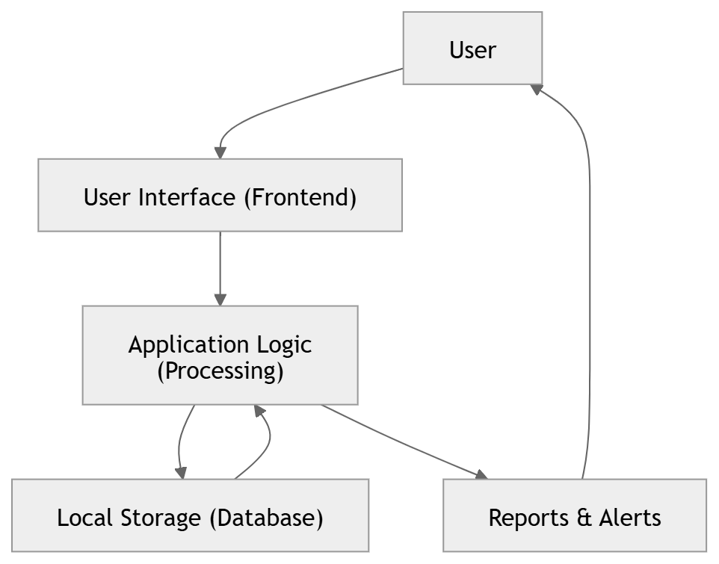

Fig 3.5: Block diagram of the system

The block diagram of the Personal Expense Tracker Application represents the overall working process of the system by showing how different components interact with each other. The system begins with the user, who acts as the primary source of input. The user enters various details such as income, expenses, categories, and budget limits through the user interface. The user interface, which is developed using frontend technologies like HTML, CSS, and JavaScript, acts as a bridge between the user and the system, ensuring smooth and easy interaction.
Once the user provides input, the data is sent to the application logic, which serves as the core processing unit of the system. This component is responsible for validating the input data, performing necessary calculations, categorizing expenses, and checking whether the expenses exceed the predefined budget. It ensures that all operations are carried out accurately and efficiently.
After processing, the data is stored in the local storage, which functions as the database of the system. This storage mechanism allows the application to save user data such as expense records and budget details within the browser, enabling quick access and offline functionality. The stored data can be retrieved whenever required for further processing or display.
Based on the stored and processed data, the system generates outputs in the form of reports and alerts. These outputs include summaries of total expenses, category-wise analysis, graphical representations, and notifications when the user exceeds the budget limit. Finally, these results are displayed back to the user through the user interface, completing the cycle.
Thus, the block diagram illustrates a continuous flow of data from the user to the system and back to the user, covering all stages such as input, processing, storage, and output. This structured design ensures efficient functioning, easy maintenance, and improved user experience in managing personal finances.

4. SYSTEM DESIGN

4.1 Introduction
System design is a crucial phase in the software development process that defines how the system will operate and how its components will interact with each other. It provides a blueprint for the implementation phase and ensures that all requirements are properly addressed.
In this project, system design includes architectural design, data flow representation, and UML diagrams. These diagrams help in visualizing the structure and behavior of the system, making it easier to understand and implement.

4.2 UML Diagrams
UML, which stands for Unified Modelling Language, is a way to visually represent the architecture, design, and implementation of complex software systems. Looking at code and understanding the system is difficult, instead we can use UML diagrams to understand the system. UML diagrams can be used to explain the components of the software to people who don’t have technical knowledge.
It is a standard language for specifying, visualizing, constructing, and documenting the artefacts of the software systems. UML is different from other common programming languages like C++, Java, and COBOL etc. It is pictorial language used to make software blueprints.
Although typically used in software engineering it is a rich language that can be used to model an application structure, behaviour and even business processes. There are 8 UML diagram types to help us model this behaviour.

4.2.1 Use Case Diagram
The Use Case Diagram not only identifies the interactions between the user and the system but also helps in clearly defining the system boundaries. It provides a high-level overview of all the functionalities offered by the application without going into implementation details. The Use Case Diagram represents the interaction between the user and the system. It identifies the different functionalities provided by the system and shows how the user interacts with them.
In this project, the primary actor is the user. The user performs actions such as logging into the system, adding expenses, viewing reports, and setting budgets. The diagram helps in understanding the overall functionality of the system from the user’s perspective.

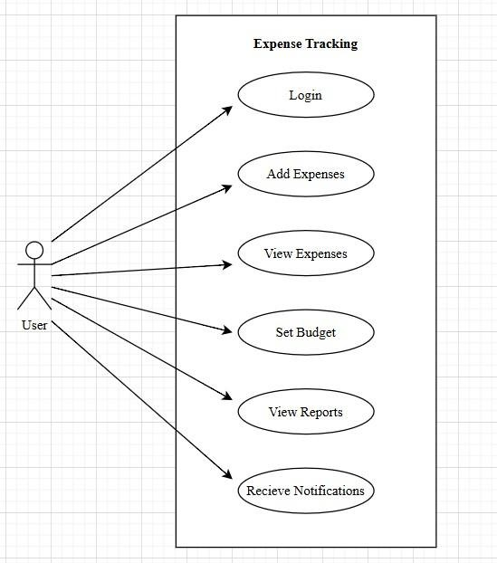

Fig 4.2.1: Use Case diagram

4.2.2 Class Diagram
Because a lot of software is based on object-oriented programming, where developers define types of functions that can be used, class diagrams are the most commonly used type of UML diagram.
The Class Diagram represents the static structure of the system. It shows the different classes, their attributes, and the relationships between them.

In the Expense Tracker system, the main classes include:
- User
- Expense
- Budget
- Report
- category
The User class manages user details, the Expense class handles transaction data, and the Budget class manages financial limits. The relationships between these classes define how data is stored and managed within the system.

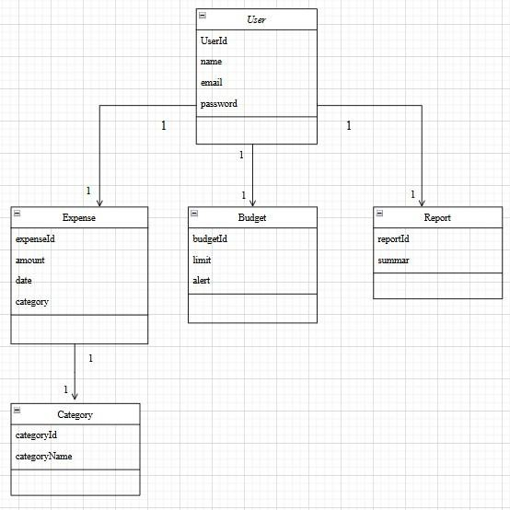

Fig 4.2.2: Class diagram

4.2.3 Activity Diagram
The Unified Modelling Language includes several subsets of diagrams, including structure diagrams, interaction diagrams, and behaviour diagrams. Activity diagrams, along with use case and state machine diagrams, are considered behaviour diagrams because they describe what must happen in the system being modelled. Activity diagram is basically a flowchart to represent the flow from one activity to another activity. The activity can be described as an operation of the system. The control flow is drawn from one operation to another. This flow can be sequential, branched, or concurrent. Activity diagrams deal with all type of flow control by using different elements such as fork, join, etc
In this project, the activity starts with user login, followed by expense entry, processing, validation, and report generation. It helps in understanding the overall process flow of the system.

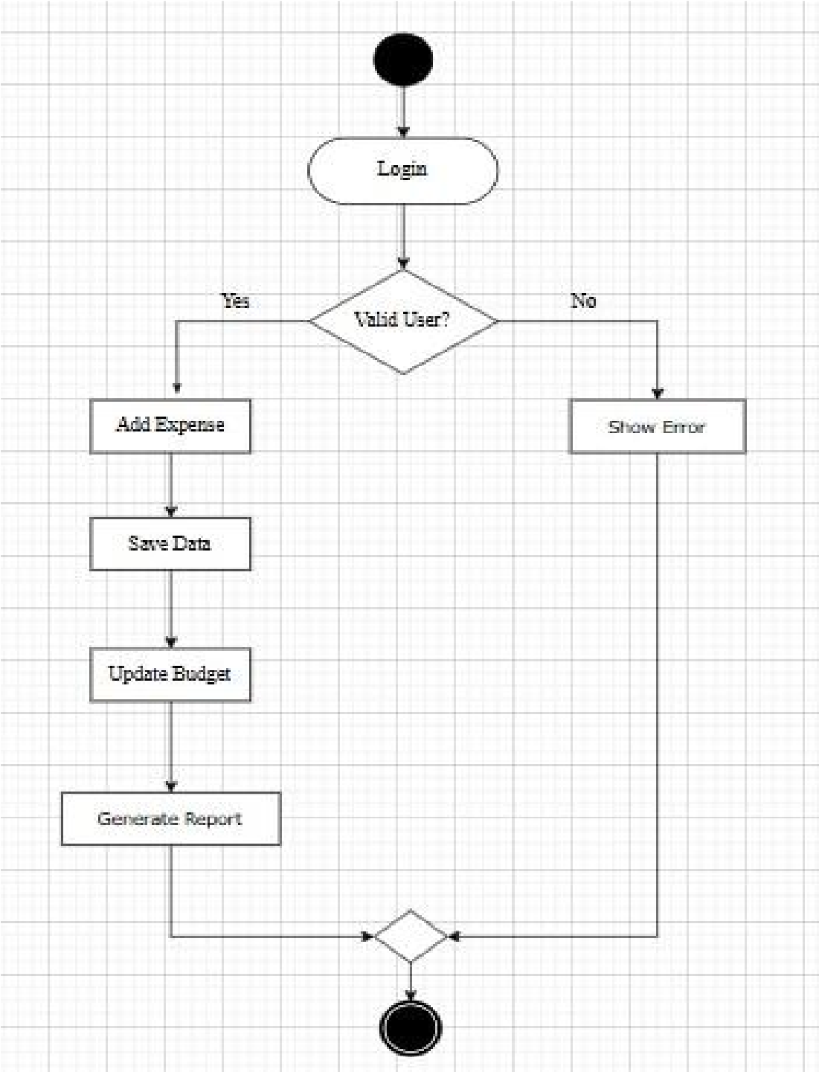

Fig 4.2.3: Activity diagram

4.2.4 Sequence Diagram
UML Sequence Diagrams are interaction diagrams that detail how operations are carried out. They capture the interaction between objects in the context of a collaboration, A sequence diagram is a type of interaction diagram because it describes how and in what order a group of objects works together. These diagrams are used by software developers and business professionals to understand requirements for a new system or to document an existing process. Sequence diagrams are sometimes known as event diagrams or event scenarios.
For example, when a user adds an expense:
- The user enters expense details
- The system processes the input
- The data is stored in the database
- The system confirms the action
This diagram helps in understanding the flow of operations step by step.

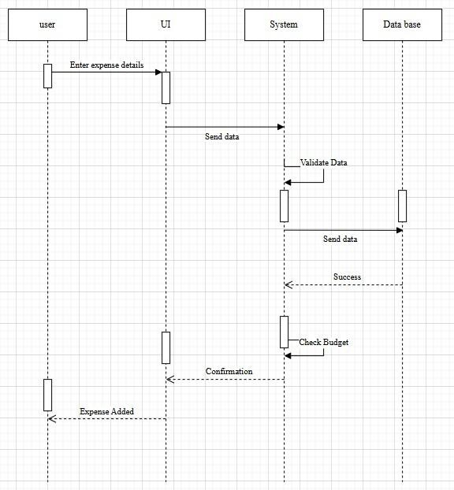

Fig 4.2.4: Sequence diagram

4.2.5 Data Flow Diagram
The Data Flow Diagram shows how data moves through the system. It represents input, processing, storage, and output.
In this project:
- The user provides input (expense data)
- The system processes the data
- The data is stored in the database
- Reports are generated as output
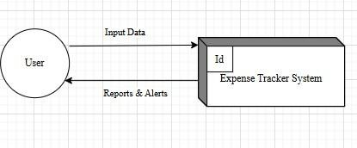

Fig 4.2.5: Data Flow diagram

5. IMPLEMENTATION AND RESULTS

5.1 Introduction
Implementation is the phase where the system design is converted into a working application. It involves writing code, integrating modules, and testing the system to ensure it meets the required specifications.
In this project, the implementation focuses on developing a user-friendly expense tracking system using modern technologies.
5.2 Technologies used

Frontend Technologies
The frontend is responsible for the user interface. Technologies such as HTML, CSS, and JavaScript (or React) are used to create an interactive and responsive interface.
- HTML is used for structuring the content
- CSS is used for styling and layout
- JavaScript/React is used for dynamic behaviour

Backend Technologies
The backend handles the logic and processing of data. It ensures that user inputs are validated and stored correctly.
- JavaScript or Java is used for implementing logic
- Functions are used to process and manage expense data

Database
The database stores all user data, including expenses and budgets.
- LocalStorage is used for storing data locally
- It ensures quick access and offline functionality
5.3 Algorithms and Flowcharts
The core of the Personal Expense Tracking System involves algorithms that manage financial data such as income, expenses, budgets, and reports. These algorithms ensure accurate calculations, efficient storage, and real-time updates for better financial decision-making.

The system primarily focuses on:
- Recording user income and expenses
- Categorizing transactions
- Monitoring budget limits
- Generating reports and alerts
These processes are implemented using structured algorithms and are represented using flowcharts for better understanding.

5.4 Control Flow of the Implementation

5.4.1 Importing Dependencies
- React: React is a JavaScript library used for building user interfaces, especially single-page applications. It helps in creating reusable components and managing the UI efficiently.
- Chart.js: is used to display graphical representations of financial data such as expense distribution and reports.
- Local Storage: is used to store user data such as expenses, income, and session details locally in the browser.

5.5 Sample Code
- JavaScript: JavaScript is a high-level, interpreted programming language used to create dynamic and interactive web applications. It is widely used for clientside development and works seamlessly with HTML and CSS.
- React.js: React is a JavaScript library used for building user interfaces, especially single-page applications. It allows developers to create reusable components and efficiently update the UI using a virtual DOM.
- React Router: React Router is a standard library for routing in React applications. It enables navigation between different components such as Dashboard, Income, Expenses, and Reports without reloading the page.
- Context API: Context API is a built-in React feature used for global state management. It helps in sharing data such as user details, expenses, and income across components without prop drilling.
- Chart.js: Chart.js is a JavaScript library used to create interactive and visually appealing charts. It is used in the project to display expense reports and financial summaries.
- Lucide React: It is an icon library used to add modern and customizable icons to the user interface, improving usability and design.
- LocalStorage: LocalStorage is a web storage API that allows storing data in the browser. It is used in the project to persist user data such as expenses, income, and login sessions.

5.5.1 Main
import { StrictMode } from 'react' import { createRoot } from 'react-dom/client' import App from './App.jsx' createRoot(document.getElementById('root')).render(
<StrictMode>
<App />
</StrictMode>,
)

5.5.2 Login Page
// State Management
const [form, setForm] = useState({ email: '', password: '' });
const [error, setError] = useState(''); const [showPass, setShowPass] = useState(false); const [loading, setLoading] = useState(false); // Handle Input Change const handleChange = (e) => { setForm({
...form,
[e.target.name]: e.target.value
});
};
// Handle Login Submission const handleSubmit = async (e) => {
e.preventDefault(); // Prevent page reload
setError(''); // Clear previous errors setLoading(true); // Start loading // Simulate delay (API call) await new Promise(resolve => setTimeout(resolve, 350));
const result = login(form.email.trim(), form.password); setLoading(false); // Stop loading if (result.success)
{ navigate('/dashboard'); // Redirect on success
} else {
setError(result.error); // Show error message
}
};
// Password Visibility Toggle const togglePassword = () => { setShowPass(!showPass);
};

5.5.3 Profile page:
// -------- STATE MANAGEMENT -------- const [tab, setTab] = useState('info'); const
[success, setSuccess] = useState(''); const
[error, setError] = useState(''); const [infoForm, setInfoForm] = useState({ name: currentUser?.name || '', email:
currentUser?.email || '',
monthlyIncome: currentUser?.monthlyIncome || '',
});
const [passForm, setPassForm] = useState({
currentPassword: '', newPassword: '', confirmPassword: '',
});
// -------- DERIVED DATA -------- const totalExpenses = expenses.reduce(
(sum, e) => sum + parseFloat(e.amount || 0), 0
);
const joinDate = currentUser?.createdAt
? new Date(currentUser.createdAt).toLocaleDateString()
: 'N/A';
const daysSince = currentUser?.createdAt
? Math.floor((new Date() - new Date(currentUser.createdAt)) / (1000 * 60 *
60 * 24))
: 0;
// -------- UPDATE PROFILE LOGIC -------- const handleInfoSave = (e) => {
e.preventDefault();
setError(''); setSuccess('');
if (!infoForm.name.trim()) return setError('Name is required');
if (!infoForm.email.trim()) return setError('Email is required'); if (isNaN(parseFloat(infoForm.monthlyIncome)) || parseFloat(infoForm.monthlyIncome) < 0) { return setError('Enter valid income');
}
const result = updateProfile({ name: infoForm.name, email: infoForm.email, monthlyIncome: infoForm.monthlyIncome
});
if (result.success) setSuccess('Profile updated successfully');
else setError(result.error);
};
// -------- CHANGE PASSWORD LOGIC -------- const handlePassSave = (e) => {
e.preventDefault(); setError('');
setSuccess(''); if
(!passForm.currentPassword) return setError('Enter current password'); if (passForm.newPassword.length < 6) return setError('Password must be at least 6 characters'); if (passForm.newPassword !== passForm.confirmPassword) return setError('Passwords do not match'); const result = updateProfile({ currentPassword:
passForm.currentPassword, newPassword:
passForm.newPassword
}); if (result.success) { setPassForm({ currentPassword: '', newPassword: '', confirmPassword: ''
});
setSuccess('Password updated successfully');
} else setError(result.error);
};
// -------- TAB SWITCHING -------- const handleTabChange = (newTab) => { setTab(newTab); setError(''); setSuccess(''); };

5.5.4 Dashboard page:
// -------- DATA & INITIAL SETUP -------- const now = new Date(); const month = now.getMonth(); const year = now.getFullYear();
const totalIncome = parseFloat(currentUser?.monthlyIncome || 0); // -------- FILTER MONTHLY EXPENSES -------- const monthlyExpenses = expenses.filter(e => { const d = new Date(e.date); return d.getMonth() === month && d.getFullYear() === year;
});
// -------- CALCULATIONS -------- const totalSpent = monthlyExpenses.reduce(
(sum, e) => sum + parseFloat(e.amount || 0), 0
);
const remaining = totalIncome - totalSpent; const savingsRate = totalIncome > 0
? ((remaining / totalIncome) * 100).toFixed(0)
: 0;
// -------- REMINDERS & CATEGORY DATA -------- const dueReminders = getDueReminders(); const catData = getExpensesByCategory(month, year);
// -------- CHART DATA -------- const chartData = { labels: Object.keys(catData), datasets: [{
data: Object.values(catData)
}]
};
// -------- BUDGET ALERT LOGIC -------- const budgetAlerts = budgets.filter(b => { const used = monthlyExpenses
.filter(e => e.category === b.category) .reduce((s, e) => s + parseFloat(e.amount || 0), 0); return used >= parseFloat(b.amount) * 0.9;
});
// -------- RECENT EXPENSES -------- const recentExpenses = expenses.slice(0, 5); // -------- CATEGORY EMOJI FUNCTION -------- function getCatEmoji(category) { const map = {
Food: '🍔', Transport: '🚗', Housing: '🏠',
Entertainment: '🎬', Health: '💊', Shopping: '🛍️',
Education: '📚', Utilities: '⚡', Travel: '✈️'
};
return map[category] || '💰';
}
5.5.4 Expenses page:
// State Management
const [form, setForm] = useState(emptyForm); const [editId, setEditId] = useState(null); const [search, setSearch] = useState(''); const [catFilter, setCatFilter] = useState(''); const [monthFilter, setMonthFilter] = useState(''); const [success, setSuccess] = useState(''); // Handle Input Change const handleChange = (e) => {
setForm({ ...form, [e.target.name]: e.target.value });
};
// Add / Edit Expense const handleSave = (e) => {
e.preventDefault();
if (!form.description.trim() || !form.amount || !form.date) return; if (editId)
{ updateExpense(editId, form); // Update existing expense
setSuccess('Expense updated!');
} else {
addExpense(form); // Add new expense
setSuccess('Expense added!');
} setEditId(null);
setForm(emptyForm); setTimeout(()
=> setSuccess(''), 3000);
};
// Delete Expense const handleDelete = (id) => { deleteExpense(id); setSuccess('Expense deleted!'); setTimeout(() => setSuccess(''), 3000);
};
// Open Add / Edit const openAdd = () => { setForm(emptyForm); setEditId(null);
};
const openEdit = (exp) => {
setForm(exp); setEditId(exp.id);
};
// Filtering Logic (Search + Category + Month) const filteredExpenses = useMemo(() => { return expenses.filter(e => { const matchSearch =
!search ||
e.description.toLowerCase().includes(search.toLowerCase()) ||
e.category.toLowerCase().includes(search.toLowerCase()); const matchCategory =
!catFilter || e.category === catFilter; const matchMonth =
!monthFilter || e.date.startsWith(monthFilter);
return matchSearch && matchCategory && matchMonth;
});
}, [expenses, search, catFilter, monthFilter]);
// Total Calculation
const totalExpenses = filteredExpenses.reduce(
(sum, e) => sum + parseFloat(e.amount || 0),
0
);
// Format Function const formatCurrency = (amount) =>
'₹' + parseFloat(amount || 0).toLocaleString('en-IN');

5.5.5 Budget page:
// -------- STATE MANAGEMENT -------- const [form, setForm] = useState({ category: 'Food', amount: '', period: 'monthly' });
const [editId, setEditId] = useState(null); const [success, setSuccess] = useState(''); const [error, setError] = useState(''); // ------- HANDLE INPUT -------- const handleChange = (e) => { setForm({
...form,
[e.target.name]: e.target.value
});
};
// -------- ADD / EDIT BUDGET -------- const handleSave = (e) => {
e.preventDefault();
setError('');
if (!form.amount || parseFloat(form.amount) <= 0)
return setError('Enter valid amount'); if (!editId) { const exists = budgets.find(b => b.category === form.category);
if (exists) return setError('Budget already exists'); addBudget(form); setSuccess('Budget added');
} else {
updateBudget(editId, form);
setSuccess('Budget updated');
}
};
// -------- DELETE BUDGET -------- const handleDelete = (id) => { deleteBudget(id); setSuccess('Budget deleted');
};
// -------- CALCULATE BUDGET USAGE -------- const budgetsWithUsage = budgets.map(b => { const used = getBudgetUsage(b); const limit = parseFloat(b.amount); const pct = limit > 0
? Math.min(100, Math.round((used / limit) * 100))
: 0;
const status = pct >= 100 ? 'over' : pct >= 80 ? 'warning' :
'ok';
return { ...b, used, pct, status };
});
// -------- TOTAL CALCULATIONS -------- const totalBudgeted = budgets.reduce(
(sum, b) => sum + parseFloat(b.amount || 0), 0
);
const totalUsed = budgetsWithUsage.reduce(
(sum, b) => sum + b.used, 0
);
// -------- CATEGORY FILTER --------
const usedCategories = budgets.map(b => b.category);
const availableCategories = CATEGORIES.filter(c =>
!usedCategories.includes(c));

5.5.6 Monthly summary page:
// -------- DATE & STATE -------- const now = new Date();
const [selectedYear, setSelectedYear] = useState(now.getFullYear());
const [selectedMonth, setSelectedMonth] = useState(now.getMonth()); const income = parseFloat(currentUser?.monthlyIncome || 0); // -------- FILTER MONTHLY EXPENSES -------- const monthlyExpenses =
expenses.filter(e => { const d = new Date(e.date); return
d.getMonth() === selectedMonth &&
d.getFullYear() === selectedYear;
});
// -------- CALCULATIONS -------- const totalSpent = monthlyExpenses.reduce(
(sum, e) => sum + parseFloat(e.amount || 0), 0
);
const savings = income - totalSpent; const savingsRate = income > 0
? ((savings / income) * 100).toFixed(1)
: 0;
// -------- CATEGORY BREAKDOWN -------- const categoryBreakdown = CATEGORIES.map(cat => { const catExp = monthlyExpenses.filter(e => e.category === cat); const total = catExp.reduce(
(sum, e) => sum + parseFloat(e.amount || 0), 0
); return {
category: cat, total,
count: catExp.length,
pct: totalSpent > 0
? ((total / totalSpent) * 100).toFixed(1)
: 0
};
}).filter(c => c.total > 0);
// -------- MONTH NAVIGATION -------- const prevMonth = () => { if (selectedMonth === 0) { setSelectedMonth(11); setSelectedYear(y => y - 1);
} else {
setSelectedMonth(m => m - 1);
}
}; const nextMonth = () => { if (selectedMonth === 11) { setSelectedMonth(0); setSelectedYear(y => y + 1);
} else {
setSelectedMonth(m => m + 1);
}
};
// -------- PDF EXPORT -------- const exportMonthlyPDF = () => { const doc = new jsPDF(); doc.text("Monthly Summary
Report", 20, 20); // Summary
doc.text(`Income: Rs. ${income}`, 20, 40); doc.text(`Total Spent: Rs. ${totalSpent}`, 20, 50); doc.text(`Savings: Rs. ${savings}`, 20, 60); doc.text(`Savings Rate: ${savingsRate}%`, 20, 70);
// Table Data
const tableData = monthlyExpenses.map(e => [
new Date(e.date).toLocaleDateString(),
e.description,
e.category,
e.amount
]);
autoTable(doc, {
head: [['Date', 'Description', 'Category', 'Amount']],
body: tableData
});
doc.save("Monthly_Report.pdf");
};

5.5.7 Reminders page:
// -------- STATE MANAGEMENT --------
const [form, setForm] = useState({ title: '', type: 'Bill Payment', dueDate: '',
notes:
'' });
const [editId, setEditId] = useState(null); const [success, setSuccess] = useState(''); const [dismissedAlerts, setDismissedAlerts] = useState(new Set());
// -------- HANDLE INPUT -------- const handleChange = (e) => { setForm({ ...form,
[e.target.name]: e.target.value
});
};
// -------- ADD / EDIT REMINDER -------- const handleSave = (e) => {
e.preventDefault();
if (!form.title.trim() || !form.dueDate) return;
if (editId) {
updateReminder(editId, form); setSuccess('Reminder updated');
} else {
addReminder(form); setSuccess('Reminder added');
}
};
// -------- DELETE REMINDER -------- const handleDelete = (id) => { deleteReminder(id); setSuccess('Reminder deleted');
};
// -------- CATEGORIZE REMINDERS -------- const categorized = reminders.reduce((acc, r) => { const today = new Date(); today.setHours(0, 0, 0, 0); const d = new Date(r.dueDate); d.setHours(0, 0, 0, 0); if (d
< today) acc.overdue.push(r);
else if (d.getTime() === today.getTime()) acc.today.push(r); else acc.upcoming.push(r); return acc;
}, { overdue: [], today: [], upcoming: [] }); // -------- ALERT FILTER -------- const alertReminders = [
...categorized.overdue,
...categorized.today
].filter(r => !dismissedAlerts.has(r.id)); // -------- DISMISS ALERT -------- const dismissAlert = (id) => {
setDismissedAlerts(prev => new Set([...prev, id]));
};

5.6 Output Screens
Result analysis is a static analysis that determines which functions in each program can return multiple results in an efficient manner.
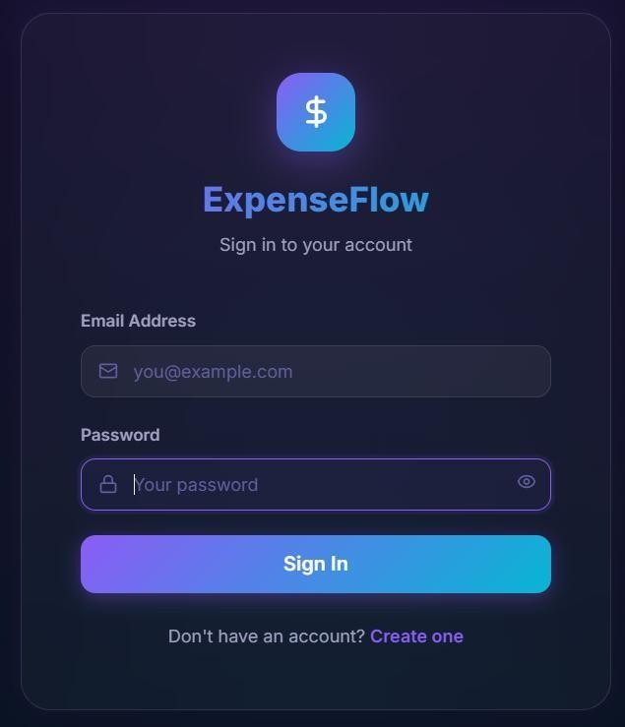

Fig 5.6.1: Output screen for login page
The above figure shows the login page of personal expense tracker system for users. It has two fields, one for the mail ID and the other for the password. The system asks for a mail ID, and then the user has to give out a mail ID. When the system asks for a password, the user has to give out the password. If the credentials are correct, the user is redirected to the dashboard, or else the user is asked to enter the correct credentials.
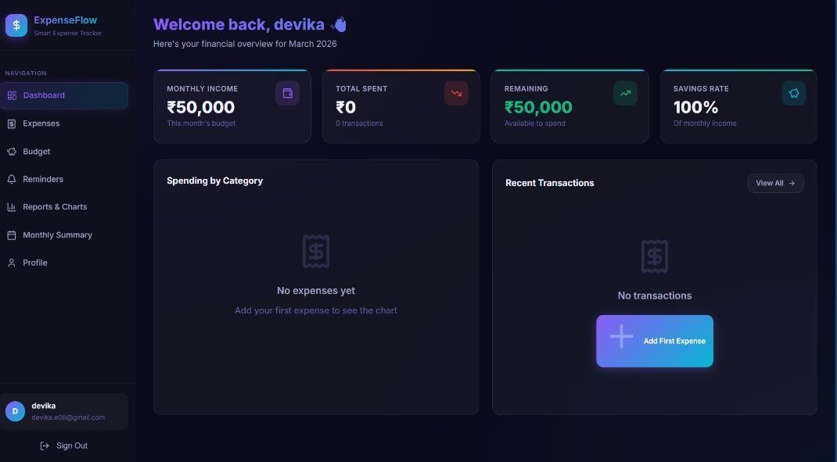

Fig 5.6.2: Output screen for dashboard Page
The figure shows the user interface of the dashboard page of a personal expense tracker system. The user is redirected to this page if they enter the correct credentials in the login page. This page shows the monthly income, Transactions, and shows the budget remained and spending categories of the user.
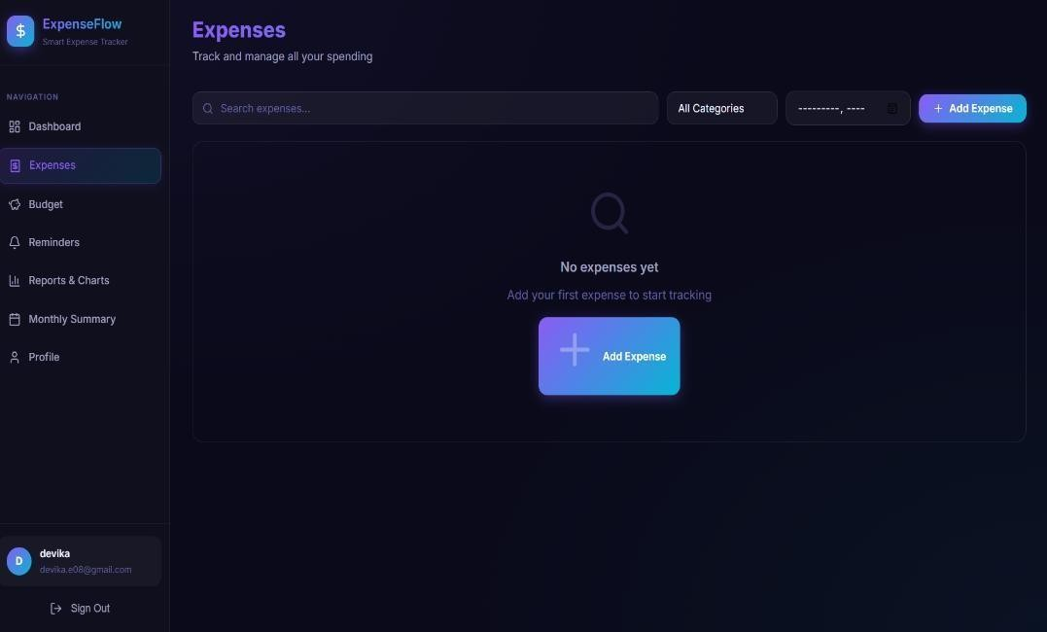

Fig 5.6.3: Output screen for expenses page
The figure shows the user interface of the expenses page of a personal expense tracker system. The user is redirected to this page if they select the Expenses option on the navigation bar(side bar). On this page, the user can add their expenses.
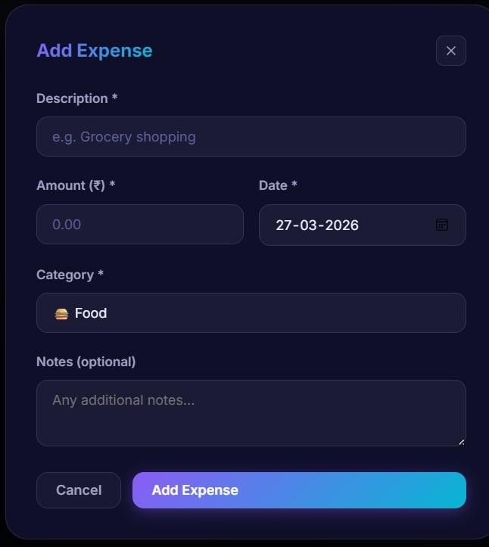

Fig 5.6.4: Output screen for Add Expense field
If the user click on “add expense” then a field with expense name, different categories and amount is displayed (fig5.6.4).
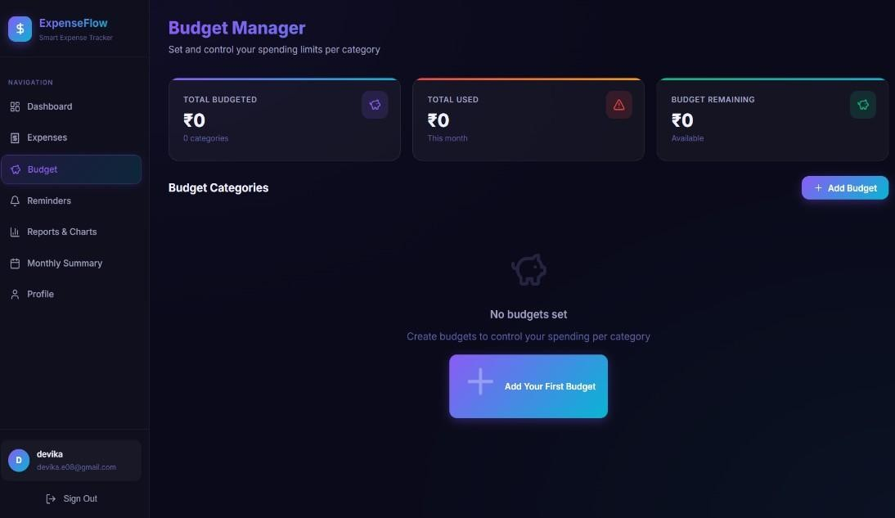

Fig 5.6.5: Output screen for Budget Page
The figure shows the user interface of the compose page of a personal expense tracker system. The user is redirected to this page if they select the Budget option on the navigation bar(side bar). On this page, the user can add their budget limit for each category and also receives a notification to the mailID if the set budget is exceeded.
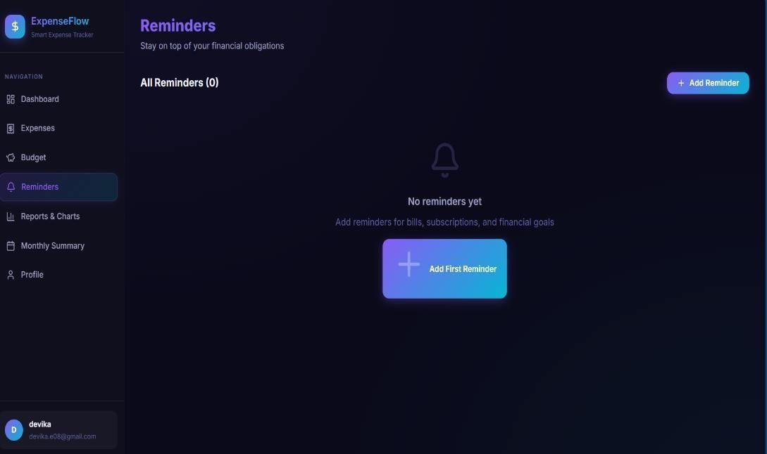

Fig 5.6.6: Output screen for Reminders Page
The figure shows the user interface of the Reminder page of a personal expense tracker system. The user is redirected to this page if they select the Reminders option on the navigation bar(side bar). On this page, the user can add their monthly bills with due date and can receive remainders when the due date is reached.
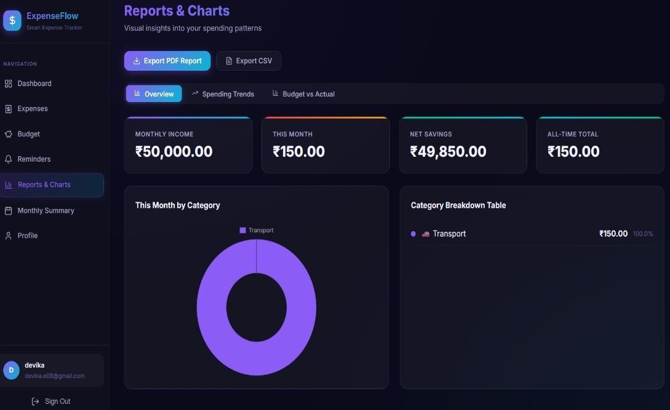

Fig 5.6.7: Output screen for Reports & charts Page
The figure shows the user interface of the Reminder page of a personal expense tracker system. The user is redirected to this page if they select the Reports option on the navigation bar(side bar). On this page, the user can view the monthly is expenses in all the categories in the visual representation(pie chart).

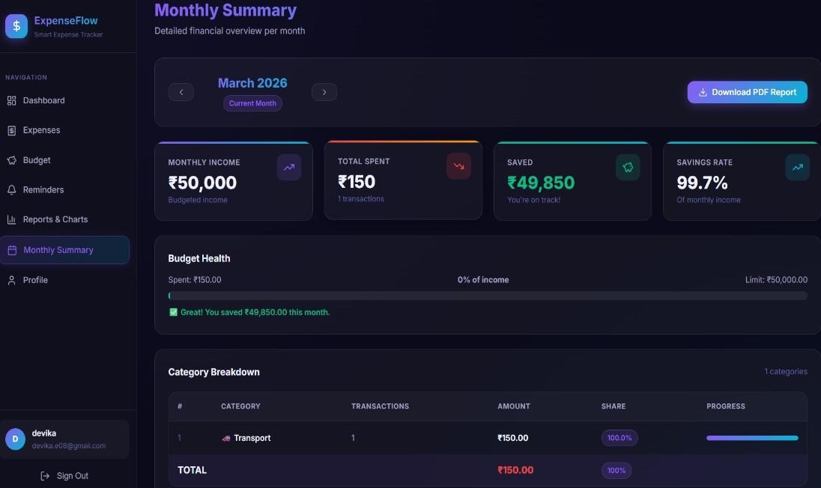

Fig 5.6.8: Output screen for Monthly summary Page
The figure shows the user interface of the Reminder page of a personal expense tracker system. The user is redirected to this page if they select the Monthly summary option on the navigation bar(side bar). On this page, the user can find their monthly transactions, budget exceeding’s/savings, and can also download this summary into pdf for monthly overview.
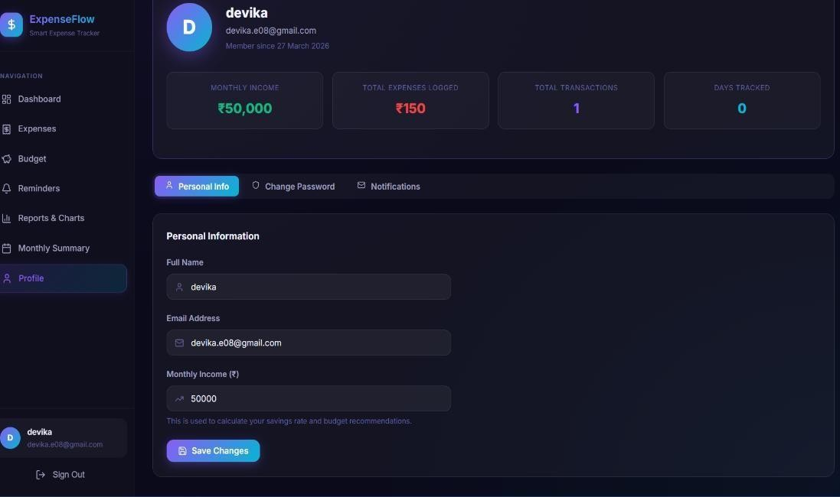

Fig 5.6.9: Output screen for Profile Page
The above figure shows the user interface of the Profile page of a personal expense tracker system. The user is redirected to this page if they select the Profile option on the navigation bar(side bar). On this page, the user see their profile information and also can change their password and update their income and all the notifications will be stored here.

6. TESTING

6.1 Introduction to Testing
Software testing is a process used to evaluate the functionality of a software application with the intent of determining whether the developed system meets the specified requirements and identifying defects. The primary goal of testing is to ensure that the application is reliable, efficient, and free from errors, thereby producing a high-quality product. In the Personal Expense Tracker system, testing ensures that all modules such as income management, expense tracking, budgeting, and reporting work correctly and provide accurate results.

6.2 Types of Tests Considered
- Testing: Application testing is a type of software testing Application performed to validate the entire application. It helps in identifying errors across all modules such as login, expense management, and report generation. This improves application quality, reduces development cost, and enhances performance
- System Testing: System testing is conducted on the complete and integrated system to evaluate whether it meets the specified requirements. In this project, it ensures that all components like user authentication, data storage, and report generation work together correctly.
- GUI Testing: GUI Testing focuses on validating the graphical user interface of the application. It checks whether elements such as buttons, forms, menus, and charts function correctly and provide a smooth user experience.
- Security Testing: Security testing ensures that user data such as login credentials and financial information is protected from unauthorized access. It verifies that proper authentication mechanisms are implemented and data stored in LocalStorage is handled securely.
6.3 Various Test Case Scenarios Considered
Test case writing is a major activity and considered as one of the most important parts of software testing. It is used by the testing team, development team as well as the management. If there is no documentation for an application, we can use the test case as a baseline document.

Table 6.3: Test cases for proposed system
TEST  CASE  ID | TEST CASE  SCEN ARIO | INPUTS | EXPECTED  OUTPUT | ACTUAL  OUTPUT | STATUS
1 | Login with valid  credentials | Enter email and password | If given the credentials are correct, it should redirect to dashboard or else you have to repeat the process. | Dashboard displayed successfully. | PASS
2 | Add Income | User has to enter the income amount | Income should be added and displayed in dashboard | Income updated correctly | PASS
3 | Add Expense | Enter amount, category, date | Expense should be recorded and reflected in total expenses | Expense added successfully | PASS
4 | Budget Limit  Exceeded | Enter  Expense  Greater Than budget | System should show alert notification | Alert displayed successfully | PASS
5 | View Reports | Click on report option | Charts and summaries should be displayed | Reports generated correctly | PASS
6 | Delete  Expense | Select expense and delete | Expense should be removed and balance updated | Expense deleted successfully | PASS
7 | Sign out | Click sign out button | User should be redirected to login  page | Logged out successfully | PASS

7. CONCLUSION & FUTURE ENHANCEMENT

7.1 Project Conclusion
It can be safely concluded from the positive outcomes that the Personal Expense Tracker system is highly efficient in managing daily financial activities in a simple and user-friendly manner. The application eliminates the need for complex financial tools by providing a straightforward solution for tracking income, expenses, and budgets.By utilizing modern web technologies, the system allows users to record transactions, monitor spending patterns, and maintain financial discipline effectively. Features such as real-time balance calculation, category-wise expense tracking, and graphical report generation help users gain clear insights into their financial status.The implementation of budget monitoring and alert notifications further enhances the usability of the system by preventing overspending and encouraging better financial planning. The use of LocalStorage ensures data persistence without requiring complex backend infrastructure, making the system lightweight and easily accessible. Overall, the project improves financial awareness, simplifies expense management, and provides a reliable platform for users to make informed financial decisions, thereby contributing to a more organized and disciplined lifestyle.

7.2 Future Enhancement
In addition to the current functionality, several enhancements can be implemented to further improve the performance and usability of the Personal Expense Tracker system. Future improvements may include integration with banking APIs to automatically fetch transaction data, reducing the need for manual entry. Implementing cloud storage can enable data synchronization across multiple devices, ensuring accessibility anytime and anywhere. Advanced features such as AI-based expense analysis and personalized financial suggestions can help users make smarter financial decisions. Additionally, a mobile application version can be developed to increase convenience and reach a wider audience. Security can be further enhanced by implementing authentication mechanisms such as OTP verification or biometric login. Through these enhancements, the application can evolve into a more intelligent, secure, and comprehensive financial management system that meets the growing needs of users.

8. REFERENCES

8.1 Journals
[1] Jonathan Sidi, Lau Sue Nee, “eSaku: An Attractive Mobile App for Students,” International Journal of Mobile Computing and Applications, (2025).
[2] Era Johri, et al., “Expense Management System Using SMS Scraping and AI/ML,” International Journal of Advanced Research in Computer Science, (2023).
[3] Garcia, Claour, “Mobile Bookkeeper Application Using OCR for Expense Tracking,” International Journal of Computer Applications, (2021).
[4] A. Sharma, R. Gupta, “Personal Expense Tracker Using Web Technologies,” International Journal of Innovative Research in Computer Science & Technology (IJIRCST), (2022).
[5] P. Verma, S. Singh, “Web-Based Financial Management System for Budget Tracking,” International Journal of Engineering Research and Technology (IJERT), (2021).
[6] Mohammed Sahel, Shaik Ismail, Shaik Sohail, Srilekha Sirasawada,
“Streamlining Personal Finances: An Expense Tracker Website Study,”
2024 International Conference on Signal Processing and Advance Research in Computing (SPARC), IEEE, 2024.

8.2 Books
- “HTML and CSS: Design and Build Websites” by Jon Duckett
- “JavaScript: The Good Parts” by Douglas Crockford
- “Learning React” by Alex Banks and Eve Porcello
- “Web Development with Node and Express” by Ethan Brown
8.3 Sites
- https://www.ieee.org/
- https://www.ijert.org/
- https://reactjs.org/
- https://developer.mozilla.org/
- https://www.chartjs.org/
- https://reactrouter.com/
- https://www.geeksforgeeks.org/

